Exercise 1: Using visuals to predict content. 練習1: 觀看來預測內容

1.

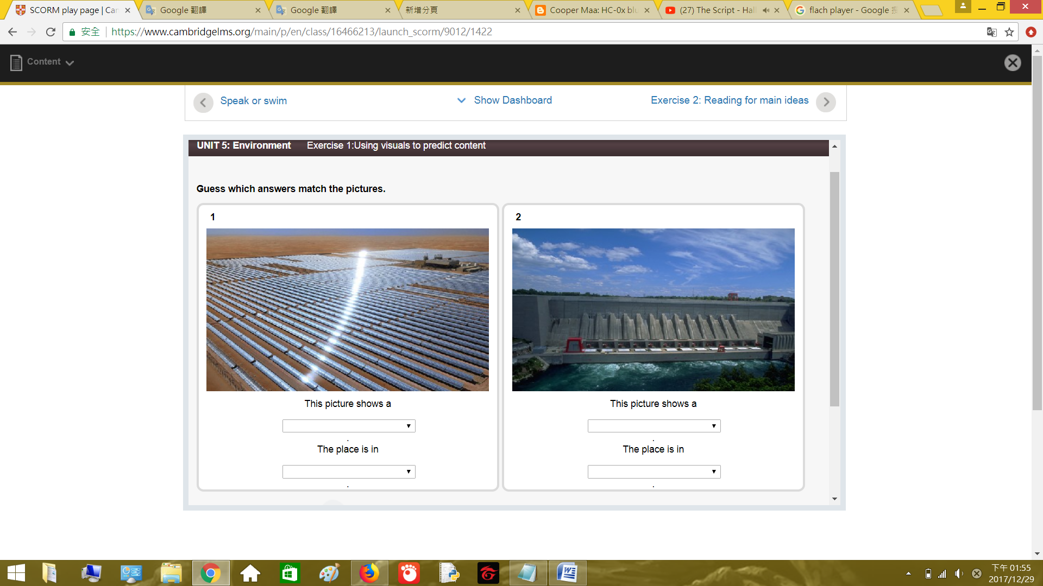

This picture shows a solar power plant.

太陽能發電廠的圖片

The place is in Abu Dhabi

在阿布扎比

2.

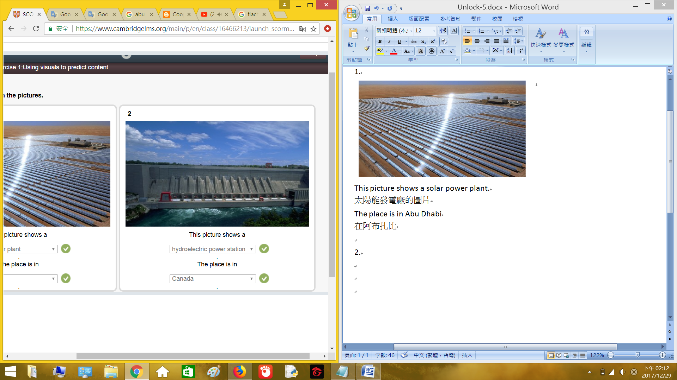

This picture shows a hydroelectric power station.

水力發電廠的圖片

The place is in Canada.

在加拿大

Exercise 2: Reading for main ideas. 練習2: 閱讀重點

Read the article. Put the ideas in the order they are mentioned.

閱讀文章.放置提到的點子順序.

The future has to be green 未來要是綠色

There is no doubt that our planet is getting warmer and it is generally agreed that is caused by the high levels of greenhouse gasses, such as carbon dioxide (CO2), in the atmosphere. There gases are created when we burn fossil fuels for energy. However, there are renewable source of energy which can be used as greener alternative to fossil fuels. This essay will look at two of the major alternative sources of energy: solar and hydroelectric. It will conclude that more of our power need should come from these energy sources if we are to reduce the speed of global warming.

不要懷疑我們的星球正在暖化,因為有高壓的溫室氣體(二氧化碳),在大氣層.當我們燃燒化石燃料取得能量時,就會產生這氣體.然而再生能源能更環保的取代化石燃料.文章有兩個主要的替代能源:太陽能和水力.結論,多使用這些能源能減少全球暖化的速度.

A lot of countries in the Gulf do not only have plenty of oil but also plenty of sun. This sunshine, together with a lot of unused desert land, means that they are the ideal locations to build solar power plants. Indeed, one of the largest solar power plants in the world is the Shams 1 plant in Abu Dhabi. The plant consists of over 258,000 mirrors, covering an area larger than 285 football pitches. The solar plant works by using the mirror to focus heat onto pipes, which are filled with a special type of oil. The heated oil is then used to produce steam, which drives the turbines that change mechanical energy into electrical energy, just like in a traditional electricity generating plant. The energy from this plant is enough to power over 20,000 home. To produce this much power from fossil fuels, over 175,000 tons of CO2 would be pumped into the air every year.

許多國家有海灣,海灣不只有充足的油也有充足的太陽.許多未使用的沙漠區域有陽光,在這些地方建立太陽能發電廠.確實,世界最大的太陽能發電廠之一在Abu Dhabi的Shams工廠.這工廠由超過258,000個鏡子組成,覆蓋這區域285個足球場的大小.太陽能發電廠的運作由鏡子將熱聚焦到管子上,管子填充特殊的油.油加熱後產生蒸氣,蒸氣啟動渦輪機將機械能轉成電能,就像傳統的發電機.工廠產生的能量足夠提供20,000家庭使用.化石燃料產生許多電能,每年超過175,000頓的二氧化碳排到空中.

A country like Canada does not have as much sun as countries in the Middle East, but it does have plenty of water. Nearly 60% of Canada’s electricity comes from hydroelectric power, making it one of few countries which generates most of its power from renewable sources. One of the most important hydroelectric power stations is the one in the Niagara River, near to the world-famous Niagara Falls. Between 50% and 70% of the water from the river goes through four huge tunnels before the waterfalls. This water then passes through special turbines which provide energy to nearby areas of Canada and United States. Once the water has passes through the turbines, it is then returned to the river after waterfalls.

加拿大這國家沒有像中東國家有許多陽光,但有豐富的水.加拿大幾乎60%的電力來自水力發電,是使用再生能源的少數國家之一.Niagara河川是重要的水力發電廠之一,靠近世界知名的Niagara瀑布.這瀑布50%到70%的水從河川通過四大隧道而來.水通過特殊的渦輪提供能量給加拿大和美國附近的區域.一旦水經過渦輪,水會回到河川之後流到瀑布.

The Middle East has nearly half the world’s solar energy potential and many countries other than Canada have significant amounts of water that can be used to generate electricity. The important question – will all these natural resources start to be used in place of burning the fossil fuels which are killing our planet? If our environment is to survive, then immediate action must be taken to ensure more power comes from renewable sources such as the sum and water.

中東將近有世界一半的太陽能潛力,許多加拿大以外的國家有相當數量的水能生產電力.重要的問題-將所有的自然資源使用在燃燒化石燃料,會殺死我們的星球?如果我們的環境要生存,必須立刻採取行動,確保更多電力是使用再生能源的太陽和水.

1. Why our planet is getting warmer.

為何我們的星球在暖化.

1. How greenhouse gases are created.

溫室氣體是怎麼產生.

1. Countries that have a lot of sunshine and desert land.

這國家有不少的陽光和沙漠.

1. A large solar power plant.

一個大型的太陽能發電廠.

1. A country that gets most of its power from renewable energy.

這國家大部分的電力是使用再生能源.

1. How water creates power.

水怎麼產生電力.

Exercise 3: Scanning to find information 練習3: 尋找來發現信息

Scan the article quickly and complete the sentences.

尋找文章快速並完成句子

1. Over 50% of the water in the Niagara River goes through the hydroelectric power generator.

在Niagara河川超過50%的水通過水力發電機.

1. Over 175,000 tons of carbon dioxide is saved every year by the Shams 1 solar power plant.

Shams 1太陽能發電廠,每年節省超過175,000噸的二氧化碳.

1. The Shams 1 power plant is bigger than 285 football pitches.

Shams 1電力場大於285的足球場.

1. Canada produces almost 60% of its energy from renewable sources.

加拿大生產將近60%的能源是使用再生能源.

1. The Shams 1 power plant can provide enough electricity for 20,000 home.

Shams 1電力發電廠能提供足夠的電力給20,00家庭使用.

1. Over 258,000 mirrors are used in the Shame 1 power plant.

超過258,000個鏡子使用在Shame 1電力發電廠.

Exercise 4: Making inferences 練習4: 進行推理

Complete the table by writing one word in each space. Use the words in the box.

完成表格,在每個空間寫入單字.使用方塊內的字.

|  |  |
| --- | --- |
| Cause 原因 | Effect 影響 |
| People burn fossil fuels around the world.  人們在世界各地燃燒化石燃料. | The amount of greenhouse gas in the atmosphere increases.  溫室氣體在大氣層增加. |
| There is a lot of greenhouse gas in the atmosphere.  不少的溫室氣體在大氣層. | The planet warms up.  星球溫度上升. |
| Sunshine on mirror at the solar plant.  陽光照射太陽能電廠的鏡子. | The sun’s heat is focused onto the pipes.  太陽的熱集中在管子上. |
| The sun heats up the special oil in the pipes.  太陽加熱管子內的特殊油. | The hot oil heats water to make steam.  熱油加熱水產生蒸氣. |
| The steam drives the turbines.  蒸氣啟動渦輪. | The mechanical energy from the turbines makes electrical energy.  機械能被窩輪轉為電能. |
| Renewable sources produce energy instead of fossil fuels.  再生能源取代化石燃料產生能量. | Less greenhouse gas goes into the atmosphere.  減少大氣層的溫室氣體. |